  - Solar Cells

In this section discussion will be made on various aspects of a solar cell: various types (generations) of solar PV cell technologies, electrical parameters, effect of temperature spectral response etc.

Types of Solar Cells

The solar cell technology has evolved dramatically; from the crystalline structure cells to thin film (ribbon) cells to the cells based on Carnot principle. Accordingly, the PV cells are classified into generations. The first generation of cell technology is based upon bulk crystalline structure of various semiconductor materials. The second-generation solar cells are thin film type cells. The third generation cells are based on entirely new principle.

- First Generation Solar Cells

Mono-crystalline silicon (where the atoms align into a large single crystal) remained predominant cell production technology for last 40 years. At the time being silicon is almost the only material used for solar cell mass production. As the most often used semiconductor material it has some important advantages:
  - In nature it can be easily found in large quantities;
  - Silicon oxide forms 1/3 of the earth’s crust;
  - It is not poisonous, and it is environment friendly, its waste does not represent any problems;
  - It can be easily melted, handled, and it is fairly easy formed into monocrystalline form;
  - Its electrical properties endurance of 125⁰ C allows the use of silicon semiconductor devices even in most harsh environment and applications.

In process of manufacturing silicon based solar cell, wafers of pure silicon are produced in first place. Then by doping appropriate impurities, large area PN junction is formed.

In techniques, pure silicon is the only widely used chemical element produced so pure. The percentage of pure silicon (semiconductor grade silicon) in material is at least 99.9999999%. Metallurgical grade silicon (98-99% purity) is produced from silicon di-oxide by reduction in specially designed furnace at 1800⁰C. By using more complex process the metallurgical grade silicon is further purified.

Monocrystalline silicon is produced from pure silicon by utilization of Czochralski (Cz) method. In this method the silicon is extracted from melt in induction oven with graphite lining at the temperature of 1415⁰C. Silicon crystal of defined orientation (called seed) is placed on a rod. In the melt, spinning the rod makes the crystal grow. The rod spinning speed comes to 10 to 40 turns per minute, whilst the movement at length comes between 1 micrometer and 1 millimeter per second. It allows production of monocrystalline rods (called ingots), which measure 30 cm in diameter and several meters in length. Individual round wafers of required thickness are sawed from the cylindrical ingot by using diamond saw. If the sides of the cylinder are cut first, making a long block, then when the wafers are cut they are square.

Monocrystalline silicon based solar cells have excellent efficiency (up to 13% in standard test conditions- STC) in converting light energy into electrical energy. The limitations of this technology are high production cost associated with wastage of precious pure silicon during sawing (almost 40-50% of the material is converted into dust) and slow process of growing the ingot.

Another method of creating a block of silicon is to melt purified silicon rocks in a rectangular block shaped mold. When the silicon is cooled slowly, it solidifies into the block shape. But in the solidifying process, the atoms do not align into large single crystal as in the Cz method. Small regions of single crystal structure form next to each other, forming a polycrystalline block of different grains.

At the boundaries between the grains, it is possible for defective atomic bonds to interfere with the current flow, and typically a slightly lower output is produced compared to equivalently processed single crystal cells. As with Cz cells, polycrystalline wafers are produced by slicing the large block. The typical efficiency of polycrystalline cell is around 10-12%.

The solar cell made of a single type of semiconductor material is called homojunction cell. Example is the silicon cell where the junction is formed by doping the silicon material with different impurities. The other PV cell materials and designs employ a heterojunction structure in which the junction is formed between two different semiconductors that have different energy band gaps. The examples of heterojunction PV cells are amorphous silicon alloy (a-Si:H), Copper Indium Diselenide (CIS), Cadmium Telluride (CdTe), Gallium Arsenide (GaAs) etc.

Independent of the methods of manufacturing the individual wafers, the solar cells based on bulk wafers have the structure as shown in fig. 5.2.1.
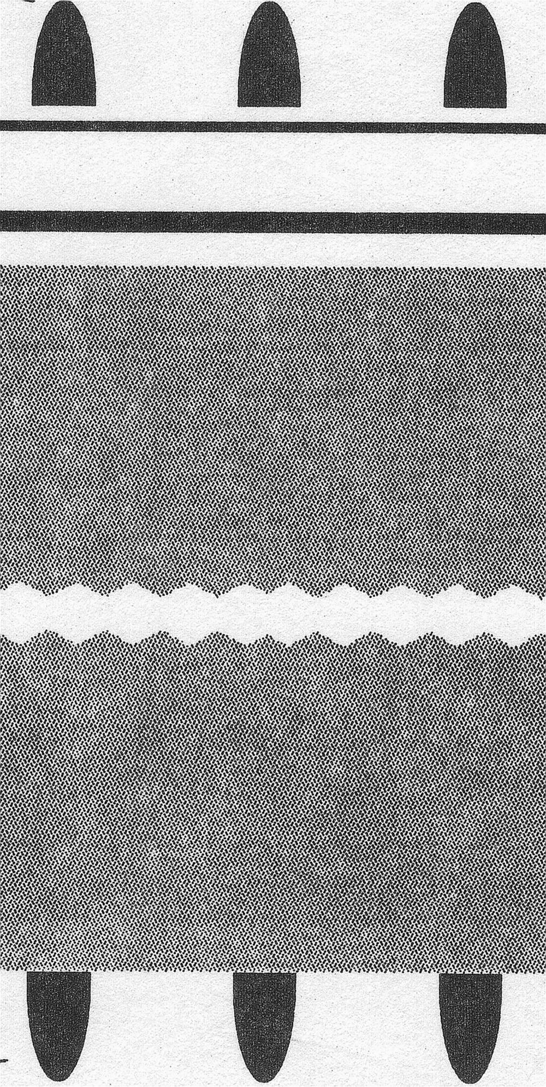
Metallic gridlines
Anti-reflective coating
N-layer
P-layer
Metallic gridlines
150 nm
300 nm
250000 nm
Fig. 5.2.1 Structure of traditional (Bulk) Solar Cell

The typical solar cell consists of a P type wafer of about 250000 nm thicknesses with rear end of the surface covered by metallic gridlines for external connections. An extremely thin layer (about 300 nm thick) of N type silicon is grown by diffusion method on top of the P type wafer to produce the PN junction. Anti-reflective conductive coating of around 150 nm thicknesses is applied to the N layer. Finally, metallic grid connection is applied for external connections. In this way an individual cell is manufactured.

- Second Generation Solar Cells

The slicing process in the previous two methods is wasteful. This is because the wafers are around 250000 nm thick, and the saw blade is about this thickness as well.

One method of producing wafers avoids most of this waste by growing a thin ribbon from the melted silicon. The ribbon is either pulled sideways off the top of the melt, or pulled up through a die. Very fast growth rates are possible, but the speed results in polycrystalline structures. However, if pulling is done very carefully and slowly, near single crystal structure is possible. As the ribbon thickness is same as that of wafer thickness, no sawing is necessary. The ribbon sheet is simply scribed and broken to produce rectangular wafers of required size.

However the surface of the wafer is not typically flat, and often bulges or waviness in the surface makes further manufacturing steps and interconnection difficult. The efficiencies of the ribbon silicon cells are similar to polycrystalline silicon cells. As with bulk cells, the materials used in thin-film cells could be amorphous silicon, CIS, CdTe, Cu₂S, GaAs etc.

- Third Generation Solar Cells

The third generation PV technology is a new concept based on different conversion principles that allow the solar energy conversion value to be more closely approached Carnot value.

Since the early days of terrestrial PV, a common perception has been that "first generation" silicon wafer based solar cells would be replaced by a "second generation" of lower cost thin film technology, probably also involving a different semiconductor. Historically, Cds, a-Si, CIS, CDTe and now thin film Si have been regarded as key thin-film candidates. Since any mature solar cell technology must evolve to the stage where costs are dominated by those of the constituent materials, be it silicon wafers or glass sheet, it is argued that PV must evolve, in its most mature form, to a "third generation" of high efficiency thin-film technology with energy conversion values double or triple the 15-20% range presently targeted from the first and second generation technology.

Unavoidable entropy production associated with light absorption that limits solar energy conversion efficiency to 86.8%. To reach this efficiency, converters must be perfectly absorbing but re-emit light with a specific spectral content. The chemical potential associated with spontaneous emission for each photon energy must have a particular value and be constant throughout the absorption volume.

Several advanced conversion approaches are theoretically proved to be capable, in principle, of meeting these requirements (tandem, hot carrier, multiple band cells). Others are bound by a slight low energy conversion efficiency of 85.4% (thermophotovoltaics). A third group (multiple electron-hole pairs) has intermediate bounds (85.9%), while the impurity photovoltaic effect has the efficiency bound 77.2%. All are appreciably higher than the bound for conventional cells (40.7%).

Tandem cells are now in commercial production with triple junction cells based on GaInP/GaAs/Ge have been developed for use on spacecraft with terrestrial efficiencies approaching 30%. Quadruple junction devices with efficiencies approaching 40% are presently under development in various parts of the world. Besides other methods are still under the research and development for commercial production.

The cost of the module based on the "third generation" PV is initially higher than conventional one at present, but due to the overall higher efficiency the operation (electricity generation) cost will be drastically reduced. The latest development in this sectors shows that there is a great prospect for the cheaper production of "third generation" PV cells within next decade.

Electrical Parameters of a Solar Cell

The graphical representation of the relation between the current and voltage produced by a solar cell is the standard form of representing the output of the cell. This graphical representation is called current-voltage curve (I-V curve). The I-V curve (fig.5.2.3) represents the snap-shot of all the potential combinations of current and voltage possible from a cell under specified environmental conditions like irradiance, air mass and surrounding temperature.
I, (P)
V
Pmax
I-V curve
Power curve
Isc
Imp
Vmp
Voc
Fig. 5.2.3 I-V curve of a solar cell
The key terminologies used in the above curve are:

Short Circuit Current (Isc) – It is the maximum current (in A or mA) produced by the cell under given conditions of irradiance and surrounding temperature. Isc is the current when the load is short-circuited, i.e. the output voltage is zero. The output power at this point is essentially zero.

Open Circuit Voltage (Voc) – It is the maximum voltage generated by the cell under given conditions of light and temperature. Voc is the voltage when the load is open-circuited, i.e. the output current is zero. The output power at this point is again essentially zero.

Maximum Power (Pmax) – It is the maximum power that can be delivered from the cell under specific environmental conditions. The point at I-V curve at which the maximum power is attainable is called Maximum Power Point (MPP).

Current at Maximum Power (Imp) – It is the current that results in maximum power. Imp is also called the “Rated” current of the cell.

Voltage at Maximum Power (Vmp) – The voltage that results in maximum power output is called Voltage at maximum power. Vmp is also called “Rated” voltage of the cell.

Fill Factor (FF) – The fill factor is a figure of merit that indicates the “squareness” of the I-V curve. It is the ratio of the actual maximum power Pmax to the unattainable but ideal power that would result from operating at Isc and Voc.

Total Area Efficiency – It is the ratio of electrical power output (typically the Pmax) to the total light power incident on the entire cell area including frames (if applicable), interconnects and pattern lines on the surface.

The above parameters are equally applicable to the modules and arrays.

Mathematically, some of the above parameters can be expressed as:

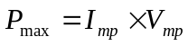 (5.2.1)

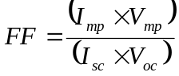 (5.2.2)

Example 5.2.1

Suppose a certain model of the solar PV module has the following parameters:
Peak Power (Wp)- 35 Watts
Open Circuit Voltage (V_{oc})- 20.8 V
Maximum Power Voltage (V_{mp})- 16.4 V
Short Circuit Current (I_{sc})- 2.3 A
Maximum Power Current (I_{mp})- 2.14A

The maximum or peak power according to formula 4.2.1 is:
P_{max} = V_{mp} x I_{mp} = 16.4 x 2.14 = 34.99 W

This value is equal to the Peak Power value (35 Wp) indicated by the manufacturer of the module.

Theoretically achievable maximum power is :
P_{ideal} = V_{oc} x I_{sc} = 20.8 x 2.3 = 47.84 W

The Fill-factor of the module is therefore (formula 4.2.2):
FF = 34.99/47.84 = 0.73

The voltage at maximum power point (MPP) of a single solar cell is approximately 0.5 volt under full sunlight. This voltage varies with the exact semiconductor materials used and is slightly affected by the temperature. The most important fact is that this voltage does not depend upon the area (or size) of the cell.

On the other hand, the current produced by a cell is the function of cell area, intensity of light, the semiconductor material used and the surrounding temperature. The larger the surface area, the more light will enter the cell and more current will be released. The typical value of Imp for a Cz monocrystalline cell is about 30 mA per square centimeter and for a Amorphous cell it is about 9 mA/cm.sq.

  - Solar Array

Solar array is a group of similar modules connected in series and parallel to increase the power delivered by the PV system. As in case of series and parallel connection of cells, series connection of modules increases the final array voltage. In this case the current supplied by the array is equal to the current produced by a single module. Parallel connection of modules increases the output current keeping the voltage level at par with the voltage produced by the single module. In both cases the total power of the array will be equal to the product of power of single module times the number of modules used in connection. The array configuration (i.e. the number of modules connected in series or parallel) is dictated by the required system voltage. The peak reverse voltage that a module can withstand also governs the number of series connected modules in an array.

The parameters of an array are same as that of a single cell or single module. The only difference is in their magnitudes.

The input to configuring an array is the final required system voltage. For example if the load is a 24 V DC pumps, only two modules are to be connected in series to produce 24 V nominal outputs. Strings of two modules connected in series further can be connected in parallel to obtained required power levels. The figure 5.4.1 below is the suggestive array configuration for a 24 V DC system.

+
_
+
_
+
_
+
_
+
_
+
_
Nominal 24 V DC
Fig. 5.4.1 Example of an array configured for 24 V DC applications

If the system requirement is 48 V batteries bank charging then four modules are to be connected in series. Number of these strings can further be connected in parallel to increase the total power. Suppose 16 modules of 40 Wp capacities are to be configured in an array to charge the bank of 48 V batteries. The array configuration can be performed in two distinct ways. In first method (parallel-series) four modules can be connected in parallel to produce a string, and four of these strings connected in series to produce 48 V nominal output (fig. 5.4.2a). In second method (series-parallel) four modules are first connected in series to make a string and finally four of these strings are further connected in parallel to obtain required power level.

In both cases the system voltage will be 48V and will deliver the same power to the battery bank.

Large size arrays are also in use in Nepal. The largest is the array installed in Bode, Bhaktapur for water pumping purpose. It has the total installed power of 40,000 Wp.

The Zero Energy House (ZEH) at the Center for Energy Studies, Institute of Engineering, uses a 6.5 kWp array to power its facilities.

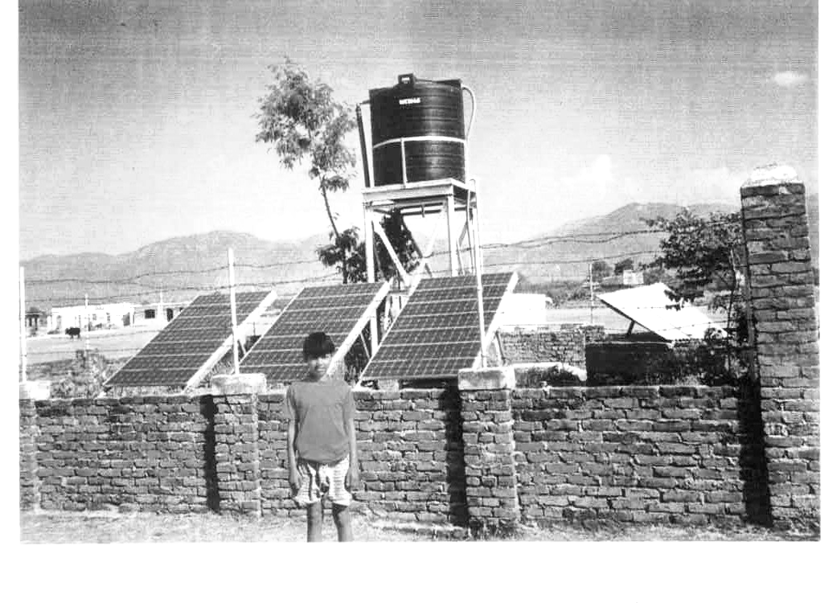
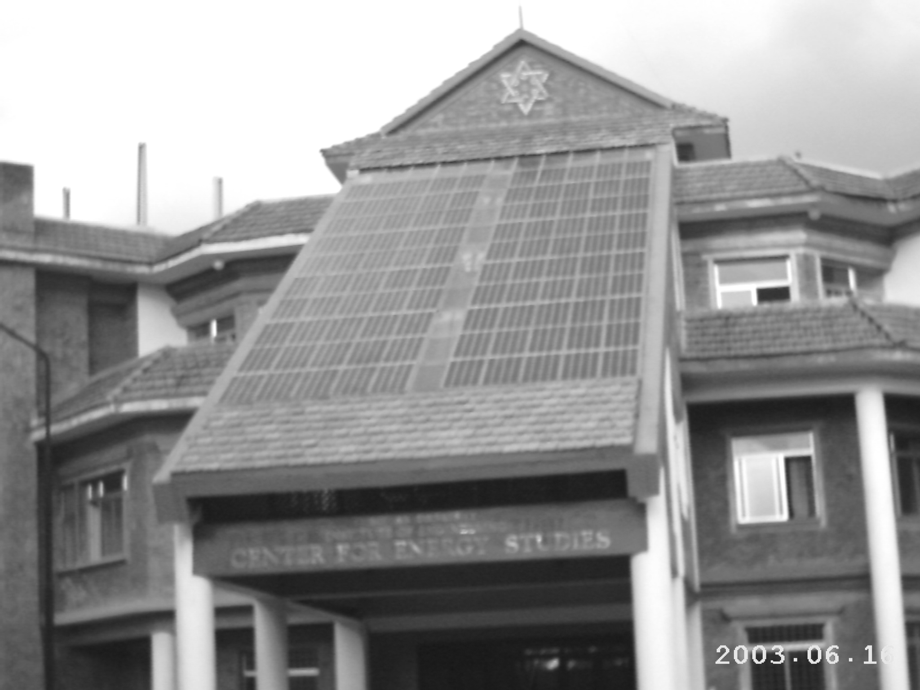

A 40 kWp array at Bode, Bhaktapur
Array used for water pumping at Ghorahi, Dang
Array used at Zero Energy House, Institute of Engineering

